**Neo Jun Kai**

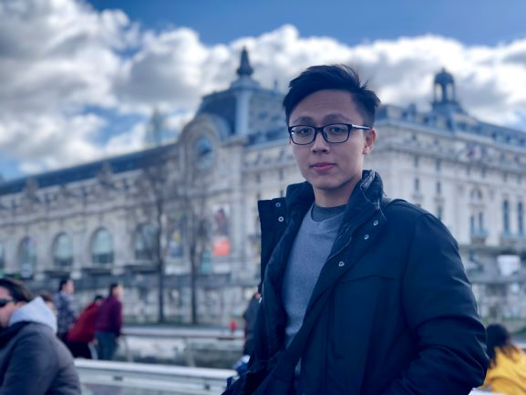78 Hougang Ave 7

Singapore 534260

Telephone: (65) 82607602

Email: [junkai30@hotmail.com](mailto:junkai30@hotmail.com)

**PROFILE**

Highly enthusiastic and committed individual that works well in a team environment. Keen learner and hardworking. Consistently striving for excellence with strong attention to details for optimal results. Currently on Summer break after completing Year 1 of studies in NUS.

**Able to start work immediately till mid/end August 2020.**

**EDUCATION**

**NATIONAL UNIVERSITY OF SINGAPORE**

Business Analytics | 2019 –

* Currently just finished Year 1 and on Summer Break. (May – August 2020)
* Cumulative Grade Point thus far: 4.7/5

**SERANGOON JUNIOR COLLEGE**

A levels | 2015 – 2016

* Academic Distinction Award for Outstanding Performance in 2016 A level Examinations (2 Distinctions in H2 Subjects)
* Relevant subjects are as followed:

H2 Mathematics (A)

H2 Economics (A)

H2 Chemistry (B)

H1 Geography (B)

**XINMIN SECONDARY SCHOOL**

GCE ‘O’ Levels | 2011-2014

**WORK EXPERIENCE**

**CITY FACILITIES MANAGEMENT**

Data administrator | March 2019 – July 2019

* Helped to settle basic administrator work such as issuing of Purchase Orders and updating excel sheets
* Designed and printed several posters some of which were to spread awareness on electricity wastage and reducing carbon footprint.

**MARIGOLD**

Promotor | January 2017 – February 2017

* Helped handled logistics for Marigold and constantly pushing for sales
* Responded to queries by customers in a professional manner

**SMILE TUTOR**

Free-lance tutor | 2016-2018

* Taught and handled students ( up to secondary school ) on academic subjects such as Math and Science
* Handled problematic students with a calm and confident demeanour
* Ability to adapt and adopt different teaching methods to suit student’s personality. Versatile and flexible.

**CO-CURRICULAR ACTIVITIES**

**CANOEING**

Member | 2015 – 2016

* Actively participated in various competitions at the tertiary level during JC.
* Achievements include:

4th team placing at National Inter-School Canoeing ‘A’ Division Championships

4th team placing at National Junior’s Canoeing Championship

Participation medal at the Singapore Canoe Marathon 2016

**SKILLS**

**LEADERSHIP:**Served as a reconnaissance 3rd Sergeant commander during time in NS, making me highly adapt at working with small groups and dealing with highly stressful situations. Being in a very physically taxing vocation that requires one to be fit and strong, I constantly try to motivate my men and my peers to work on their physical health by doing trainings together and pushing on the weaker ones. I organize several training sessions even after working hours in hopes that not only will their physical health improve but also their mental fortitude and tenacity.

**PROGRAMMING:**

* Basic knowledge in Python and Java language. Well-versed with the concept of Object-Oriented Programming but needs practice with regards to functional programming concepts
* Basic knowledge with regards to using Tableau, R and Excel to generate Data Visualization models.
* Basic knowledge in mySQL and MongoDB querying
* Keen to learn more during internship

**SOFT SKILLS:**

* Fluent in Microsoft word, powerpoint and general IT skills.
* Fluent in English and Chinese, possess good English writing skills
* Works well in small groups